

Nana Daasebre Kwaku Adu-Gyamfi

02852027

Department of Computer Science and Information Systems, Ashesi University

CS341_C: Web Technologies Final Exams

Mr. Kwadwo Osafo-Maafo

December 18th, 2025

Introduction
ComeQuick is a seamless ride-hailing web-application that is designed to fill that gap of unavailable forms of transportation for both passengers and drivers in isolated areas. This problem stems from the struggle of getting rides to places like Berekuso for example, as drivers fear to run at a loss to go back all the way to Accra after the ride without picking a passenger back. ComeQuick gives both drivers and passengers the chance to easily go to these marginalized locations without the fear of getting rides back.
1. Who will use this platform?
The platform serves two key groups:
a) Passengers
Individuals (students, staff, visitors, and residents around isolated locations) who frequently struggle to get rides to and from these areas.
b) Drivers
Uber/Bolt drivers, campus shuttle drivers, local taxi drivers, and independent drivers who want a reliable way to find passengers in areas where they normally fear returning empty.

2. What problem does this platform solve?
Some locations, such as Ashesi University’s campus and other hilly or remote areas, create a transportation gap because:
- Drivers avoid the area due to fear of driving back empty.
- Passengers struggle to find rides because few drivers are willing to go there.
- No simple, trusted system exists for connecting drivers and waiting passengers in these areas.
- Passengers also lack a way to quickly see which drivers are available and feel safe choosing among them.
- This results in long waiting times, inconsistent transportation, and frustration for both drivers and passengers.

3. What is the solution?
This project introduces a location-based ride connection platform where:
- Drivers scan a QR code posted at the isolated location (e.g., at Ashesi campus, entrance gate, or parking area), which immediately shows them:
  - All currently available passengers requesting rides
  - Passenger pickup points
  - Destinations
  - Requested time window (optional)
This is simple, fast, and requires no signup struggle or full app installation.
- Meanwhile:
  - Passengers create accounts on the platform for quick ride requests that appear on the driver’s dashboard when they scan the QR.
4. How the QR-based system works
- Passenger submits a ride request online (mobile-friendly).
- A driver arrives at the location → scans the posted QR code.
- The QR code instantly opens a driver-only interface showing live passenger requests near that location.
- Before accepting any passenger, the driver provides minimal but essential verification info such as:
  - Full name
  - Phone number
  - Car model & color
  - License plate number
- Driver selects a passenger →passenger receives driver details → ride is confirmed → Driver navigates to pick up location using the google map integration.
- This system solves all fears:
  - Passengers know a verified driver is picking them.
  - Drivers know there are visible, ready passengers in the area, reducing risk of returning empty.
  - The school/location doesn’t need Uber/Bolt integration; the system is independent.

5. What are the core system functions?
Passenger Functions:
- Create an account
- Request for a ride based on location and destination
- View confirmation once a driver accepts
- See driver details before entering the vehicle
- Cancel ride if plans change
Driver Functions:
- Scan QR to access the platform
- Perform quick one-time verification
- View list of passengers currently needing rides
- Accept a passenger request
- Mark ride as completed
Admin Functions (Optional for future enhancements):
- Manage QR codes for different locations
- Monitor ride activity
- Validate suspicious driver accounts

6. Use of AI
Tools used: Lovable, Gemini Pro (via Antigravity extension), Claude
Extent of use:
- Lovable-dev: used as the initial baseline generator for a plain React (Vite) template. It provided the scaffolding for Shadcn UI components and the core project structure, which was then heavily modified and extended manually.
- Gemini (Image Generator): Used to generate the conceptual assets and base imagery for the ComeQuick logo and splash screen branding.
- Canva (AI Design Tool): Used to refine the logo design, pick a cohesive and modern color palette, and design the consistent visual theme across the web-app.
- Claude (Anthropic): used as a primary AI coding assistant for pair programming, refactoring components (e.g., modularizing ‘MapPicker’), implementing backend security fixes (null checks, deleted data filtering), and structuring documentation (Readme.md). Also utilized for deep debugging of complex geospatial logic, specifically resolving initial rendering issues with Leaflet maps and ensuring smooth integration with the Google Maps GPS API. Used for assisting with clear error handlers to help with manual debugging. This also assisted in debugging my framer-motion errors used when designing the SplashScreen.tsx file. Screenshots of some of these AI-refactored codes are seen in the appendix.

8. Summary
This project aims to eliminate the long-standing transportation problem in isolated locations by using a simple QR-based mechanism to match drivers with waiting passengers. By providing visibility, safety, and convenience on both sides, the platform creates a sustainable ride system that benefits drivers, passengers, and the entire community.

Appendix
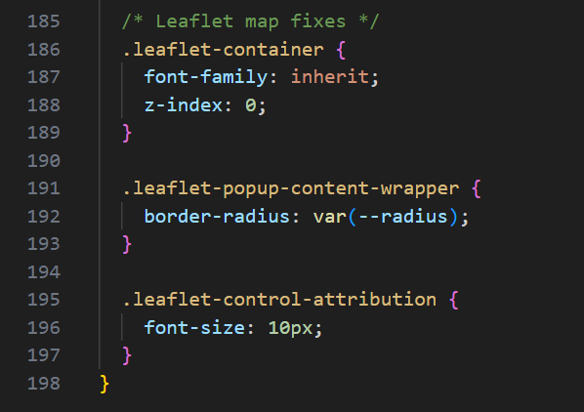
(Leaflet Map container obtained from Claude)
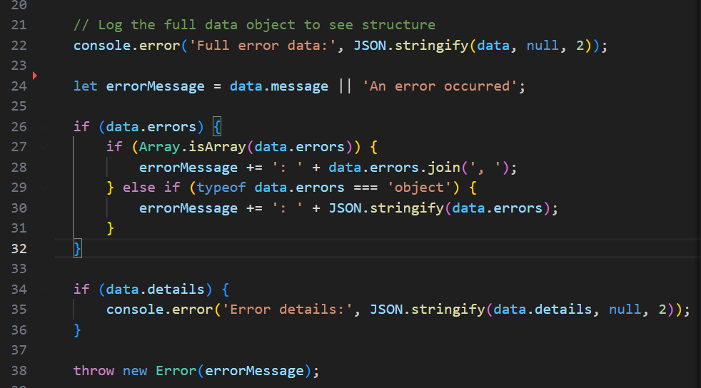
(Clear error handling messages to help understand the issue)

